**旋转**

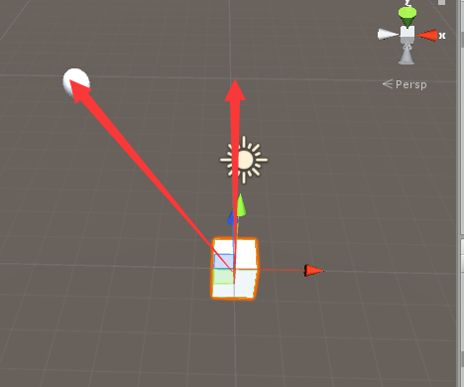

**代码：**

public Transform sphere;

Vector3 dir;

void Update()

{

//求得cube到sphere的方向向量

dir = sphere.position - transform.position;

//旋转：---适用于知道旋转角度并且是绕着自身的某个轴旋转

//transform.Rotate(dir, 45);

//知道旋转角度

//transform.rotation *= Quaternion.Euler(30, 0, 0);

//不知道旋转角度，只知道旋转到某个目标，并且是自身z轴看向该目标

//Quaternion.LookRotation();

//LookRotation:其实是绕着自身Y轴旋转，Z轴朝向某个目标

//transform.rotation =Quaternion.LookRotation(sphere.position);

//Quaternion qua = Quaternion.LookRotation(sphere.position);

//由快到慢旋转

//参数1：自身的旋转

//参数2：到目标的旋转

//参数3：旋转的比例值

//transform.rotation = Quaternion.Lerp(transform.rotation,qua,Time.deltaTime*0.5f);

//匀速旋转：

//transform.rotation=Quaternion.RotateTowards(transform.rotation, Quaternion.LookRotation(sphere.position), 10 * Time.deltaTime);

//实现: 转向目标,然后朝着目标移动

transform.rotation = Quaternion.RotateTowards(transform.rotation, Quaternion.LookRotation(sphere.position), 10 * Time.deltaTime);

if(Vector3.Angle(transform.forward,dir)<0.5f)

{

transform.LookAt(dir);

//Debug.Log("已将朝向了");

if(Vector3.Distance(transform.position,sphere.position)>3f)

{

//移动：

transform.position = Vector3.MoveTowards(transform.position, sphere.position, 10 * Time.deltaTime);

}

}

}